
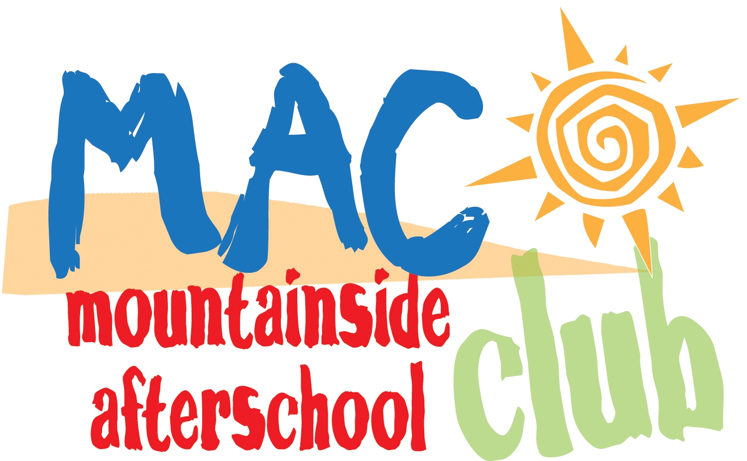

TO ENROLL: Fill out the entire enrollment packet for each child. Please print clearly and fill in all areas that apply.

Attach a $50.00 per family Registration Fee –paid every year (non-refundable)

Return this application to the Director or mail directly to:

Bar-T Main Office
18753 North Frederick Avenue
Suite 203
Gaithersburg, MD 20879

TUITION

5 days 4 days 3 days 2 days

AM & PM $489/month $391/month $293/month $195/month

AM ONLY $253/month $202/month $151/month $122/month

PM ONLY $408/month $326/month $244/month $163/month

Payment schedule is August 1st through May 1st

Circle Your Plan Drop In Only____

5 Days AM PM BOTH

4 Days AM PM BOTH

3 Days AM PM BOTH

2 Days AM PM BOTH

1 Day AM PM BOTH

Circle Your Days:
AM PM
MONDAY MONDAY
TUESDAY TUESDAY
WEDNESDAY WEDNESDAY
THURSDAY THURSDAY
FRIDAY FRIDAY

MAC
2012-2013
Registration
For Office Use Only
Dir./Teacher Initials _______

Received Date _______

Payment Type/CK # _______

Entered By/Date _______

Start Date_________________________

Childs Name______________________Boy____Girl_____Birthdate ____/____/____Grade (Fall 2012)____

Childs Name______________________Boy____Girl_____Birthdate ____/____/____Grade (Fall 2012)____

Childs Name______________________Boy____Girl_____Birthdate ____/____/____Grade (Fall 2012)____

Child lives with:
Home Phone__________ Mother_____ Father_____ Both_____

Address__________________________________________________

_________________________________________________________

Person who should be contacted first:

Parent/Guardian 1_________________________________________

Is this person financially responsible for the account?
Yes___ No___

Address: (if different from above)_______________________________

___________________________________________________________

Home Phone:_________________ Work Phone:________________

Cell Phone:________________ E-Mail_________________________
**Please provide email address to receive important updates and information

Person who should be contacted if Parent/Guardian 1 cannot be reached:

Parent/Guardian 2_________________________________________

Is this person financially responsible for the account?
Yes___ No___

Address: (if different from above)__________________________________

___________________________________________________________

Home Phone:_________________ Work Phone:________________

Cell Phone:________________ E-Mail_________________________

IMPORTANT – PLEASE COMPLETE:

(Parents are always contacted first with emergencies. Please list additional contacts in the event we are unable to reach you).

Emergency Contact:

Home Phone: Work:

Cell: ___________________________

Please list ALL persons authorized to pick-up child including parents/siblings.

______

______

A 10% discount on tuition is given for additional siblings enrolled in the program.

You will receive an email confirmation of enrollment within a few weeks after we receive this enrollment form.

Incomplete applications will delay the processing of your enrollment.

PAYMENT DUE DATES ARE AS FOLLOWS:

August 1st for September January 1st for February
September 1st for October February 1st for March
October 1st for November March 1st for April
November 1st for December April 1st for May
December 1st for January May 1st for June

Bar-T Main Office
18753 North Frederick Avenue
Suite 203
Gaithersburg, MD 20879
(301) 948-3172

PLEASE MAKE ALL CHECKS PAYABLE TO:

MOUNTAINSIDE EDUCATION & ENRICHMENT (MEE)

Mountainside Afterschool Club Agreement:

- I understand that there is a $50.00 annual registration fee per family that is
due upon enrolling. I understand that payment is due on the first of every
month. I understand that payment can be sent in with my enrollment
application mailed in or called into the Main Office at 301-948-3172. If
payment is not received, my child will not be able to attend.

2. I understand that once my application is accepted, I will receive an email
confirmation acknowledging my child’s enrollment in Mountainside Afterschool Club. All invoices will be sent to the email address listed on the registration page.

3. I understand that any absences due to illness, vacation, days MAC is closed
due federal holidays or whatever reason will not result in a refund or adjustment of
tuition.

4. I hereby grant to M.A.C. and to its employees, agents and assigns the right to
photograph or videotape my dependent and use the photo or video and or other
digital reproduction of him/her or other reproduction of his/her physical likeness,
image or voice for publication processes, whether electronic, print, digital or electronic publishing via the Mountainside website. When images are used, M.A.C. never provides specific information about any individual or provides any identifying information in that regard.

5. I give permission to M.A.C. to transport my child from Mountainside at 2914
Roderick Rd. Urbana, MD to either Urbana Elementary School, Urbana Middle or Centerville
Elementary School and transport and transport in the afternoon from Urbana
Elementary, Urbana Middle and Centerville to Mountainside. I understand they will travel by MAC
bus or School bus. I agree to drop off my child at Mountainside no earlier than 6:30 a.m. and pick up my child at Mountainside no later than
6:30 p.m. each day. I understand that any belongings that my child brings are
his/her responsibility.

Name of child (ren): ______________________________________

Parent/Guardian Name____________________________________

Parent/Guardian Signature______________________ Date________

